**Assignment-1**

(Microsoft Word Assignment)

**Office Automation Tools - (2302DU004)**

Department of Computer Engineering

4th Semester

(Darshan Institute of Engineering & Technology

for Diploma studies)

**SUBMITTED BY**

|  |  |
| --- | --- |
| **Student Name** | **Roll Number** |
| Aryan Vala | 119 |



Quantum Computing

**1** **What is Quantum Computing** 2

**2** **Superposition and Entanglement** 2

**2.1** **Superposition:** 2

**2.2** **Entanglement:** 3

**3** **Quantum Computer** 3

**4** **Types of quantum computer:** 4

**4.1** **Superconducting Qubits:** 4

**4.2** **Trapped Ion Quantum Computers:** 4

**4.3** **Topological Quantum Computers** 4

**4.4** **Photonic Quantum Computers** 4

**5** **How a Quantum Computer Works:** 5

Table of Figures:

Figure 1 Qubit 2

Figure 2 Entanglement 3

Figure 3 Quantum Computing 3

Figure 4 Working 5

**Quantum Computing**

# **What is Quantum Computing**

**Quantum Computing** is the process of using **quantum-mechanics for solving complex and massive operations quickly and efficiently**. As classical computers are used for performing classical computations, similarly, a Quantum computer is used for performing Quantum computations. Quantum Computations are too complex to solve that it becomes almost impossible to solve them with classical computers. The word **'Quantum' is derived from the concept of Quantum Mechanics in Physics** that describes the physical properties of the nature of electrons and photons. Quantum is the fundamental framework for deeply describing and understanding nature. Thus, it is the reason that quantum calculations deal with complexity.

For performing Quantum calculations, a Quantum Computer is used that is dissimilar to a classical computer. Although the concept of quantum computing came earlier, it didn't gain much popularity then.

# **Superposition and Entanglement**

## **Superposition:**

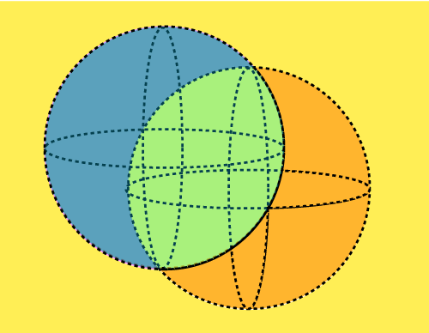A Quantum deals with the smallest particles found in nature, i.e., electrons and photons. These three particles are known as **Quantum particles**. In this, superposition defines the ability of a quantum system to be present in multiple states (one or more) at the same time.

Figure 1 Qubit

In a **quantum Computer**, a qubit can exist in a superposition of states. For example, it is able to constitute both 0 and 1 concurrently. This property permits quantum computers to assess a couple of opportunities at the same time.

## **Entanglement:**

**Entanglement** defines a very strong correlation between the quantum particles. These particles are so strongly linked that even if we place one particle at one end of the universe and one at the other end, both of them dance instantaneously.

Figure 2 Entanglement

**Entanglement** occurs while qubits become correlated. If you have entangled qubits, measuring one right now determines the country of the opportunity, no matter the space among them. For example, if one qubit is measured as "up," the other is confident to be "down." This belonging is regularly defined as "**spooky movement at a distance.**"

# **Quantum Computer**

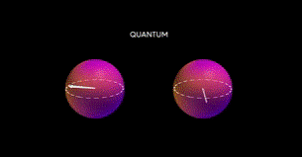A **quantum computer** is a computer that leverages the principles of quantum mechanics to approach statistics distinctly compared to classical computer structures. Instead of the use of classical bits (0s and 1s), quantum computer structures use quantum bits or qubits, which can exist in superposition and be entangled with exceptional qubits.

Figure 3 Quantum Computing

# **Types of quantum computer:**

## **Superconducting Qubits:**

* **Description**: Superconducting qubits are one of the most widely researched types of quantum computing. They are made from superconducting materials that exhibit quantum mechanical behavior when cooled to extremely low temperatures. These qubits are manipulated using microwave pulses.
* **Examples**: IBM's Quantum Computers, Google’s Sycamore Processor, and Rigetti's Aspen processor.
* **Pros**: Mature technology, strong coherence times, relatively large scale.
* **Challenges**: Requires extremely low temperatures, high error rates in large systems.

## **Trapped Ion Quantum Computers:**

* **Description**: In this type, qubits are represented by individual ions trapped in electromagnetic fields. Lasers are used to manipulate and entangle the qubits.
* **Examples**: IonQ, Honeywell's quantum computers.
* **Pros**: High fidelity and long coherence times.
* **Challenges**: Scaling up to large numbers of qubits, slower processing times compared to other methods.

## **Topological Quantum Computers**

* **Description**: Topological quantum computing relies on anyons (exotic particles) and uses their topological properties to store and manipulate information in a more stable manner. The goal is to make qubits more resistant to errors.
* **Examples**: Microsoft’s StationQ project is pursuing this approach.
* **Pros**: Potential for low error rates due to the robust nature of topological qubits.
* **Challenges**: Still in the early stages of development and research.

## **Photonic Quantum Computers**

* **Description**: These quantum computers use photons (light particles) as qubits. Photons are manipulated using optical elements like beam splitters, phase shifters, and detectors.
* **Examples**: Xanadu Quantum Technologies, PsiQuantum.
* **Pros**: Fast, can be implemented at room temperature, and has a natural advantage in communication over long distances.
* **Challenges**: Requires precise control of photons, difficult to scale up to large systems.

# **How a Quantum Computer Works:**

Classical Output

**Result**

**Measurement**

**Quantum Gates**

**Superposition**

**Entanglement**

**Qubit-2**

**Superposition**

**Qubit-1**

Figure 4 Working

1. Qubits are placed in superposition (both 0 and 1).
2. Quantum gates are applied to manipulate the qubits.
3. Entanglement occurs, linking qubits together.
4. Measurement collapses the state into a classical output (0 or 1).

|  |  |  |  |
| --- | --- | --- | --- |
|  |  |  |  |
|  | Series 1 | Series 2 | Series 3 |
| Computer | 4.3 | 2.4 | 2 |
| Quantum Computer | 2.5 | 4.4 | 2 |
| Some other computer | 3.5 | 1.8 | 3 |
| Mac | 4.5 | 2.8 | 5 |
|  |  |  |  |
|  |  |  |  |
|  |  |  |  |
|  |  |  |  |